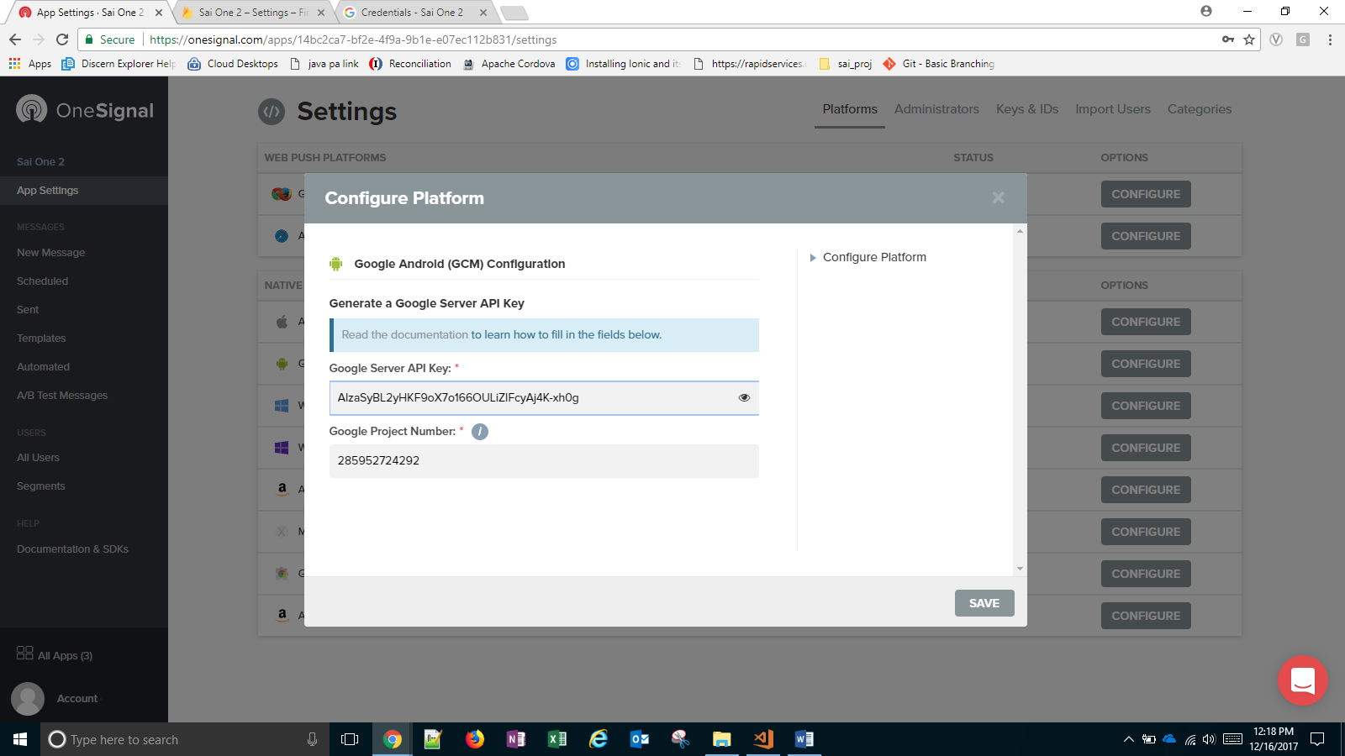

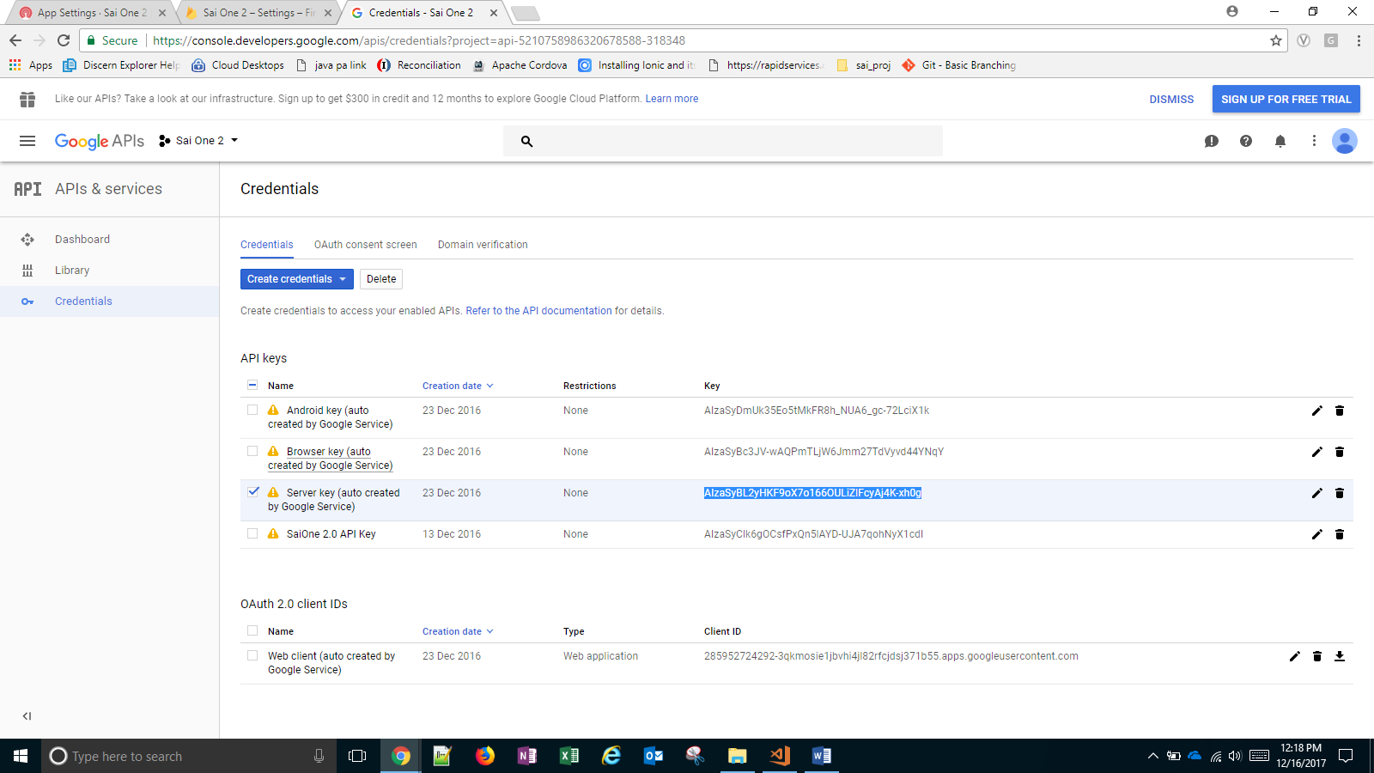

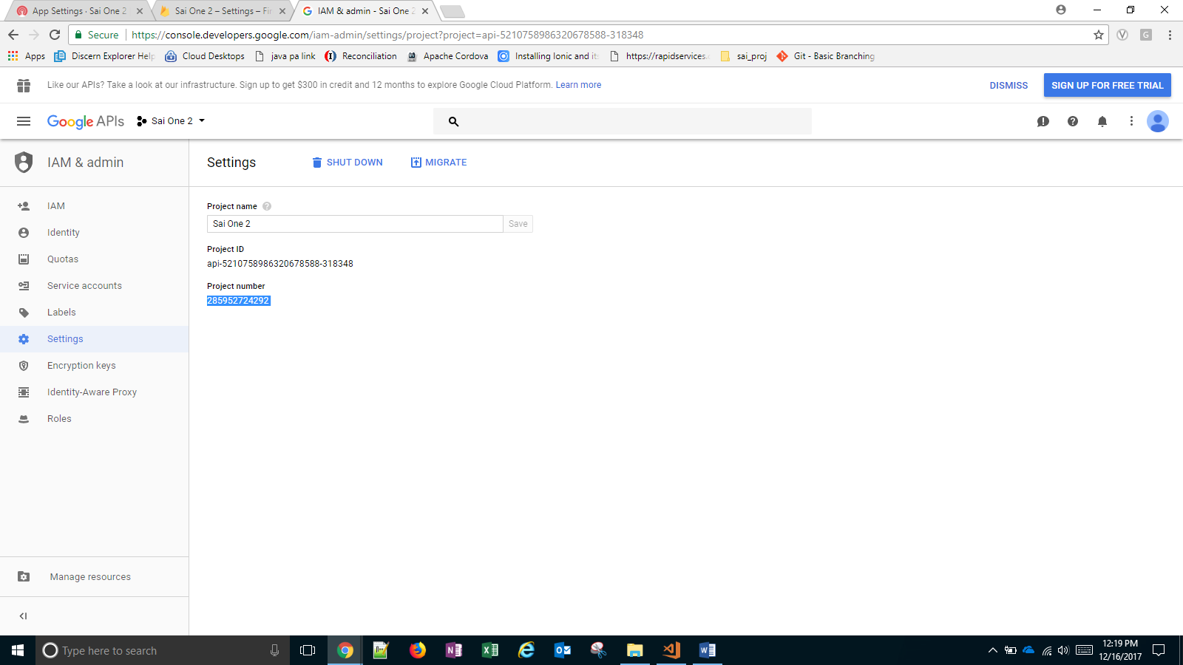

Add cordova plugin - ionic cordova plugin add onesignal-cordova-plugin --save

// Enable to debug issues.

// window.plugins.OneSignal.setLogLevel({logLevel: 4, visualLevel: 4});

var notificationOpenedCallback = function(jsonData) {

console.log('notificationOpenedCallback: ' + JSON.stringify(jsonData));

};

window.plugins.OneSignal

.startInit("YOUR_APPID")

.handleNotificationOpened(notificationOpenedCallback)

.endInit();

// Call syncHashedEmail anywhere in your app if you have the user's email.

// This improves the effectiveness of OneSignal's "best-time" notification scheduling feature.

// window.plugins.OneSignal.syncHashedEmail(userEmail);

